- With vibe coding implement the playwright/typescript or any other tool which you work say Selenium/Python
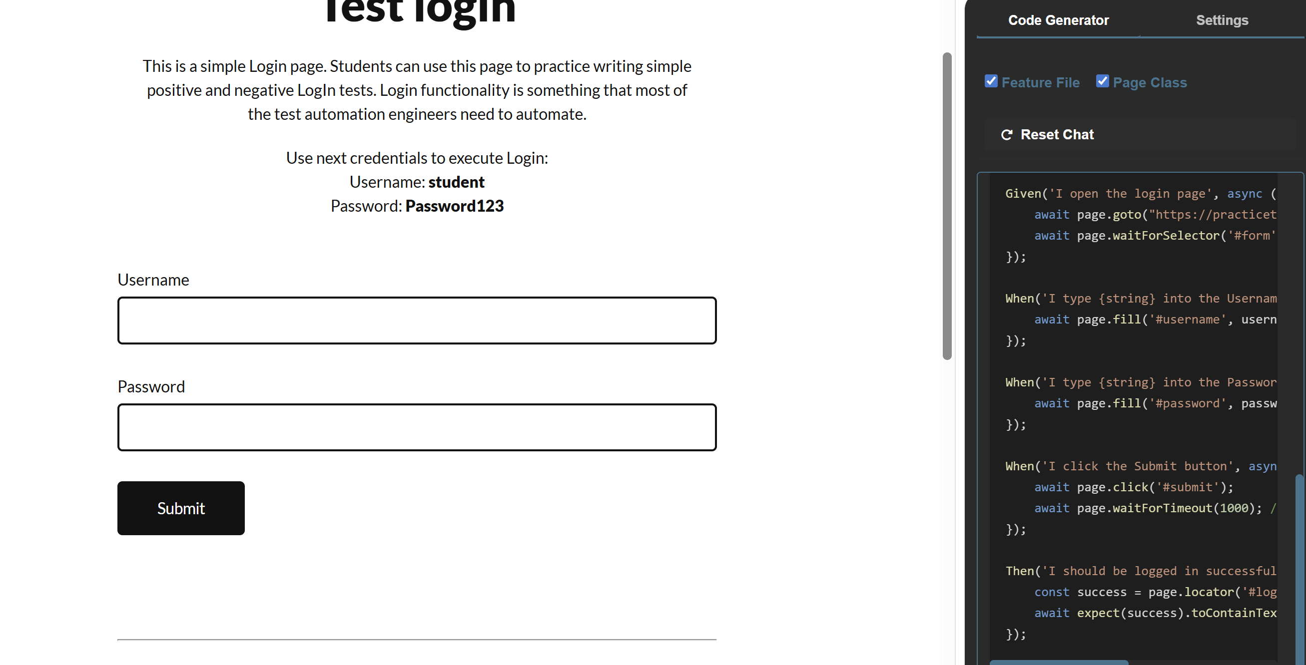

2.used bug magnet to fill the form

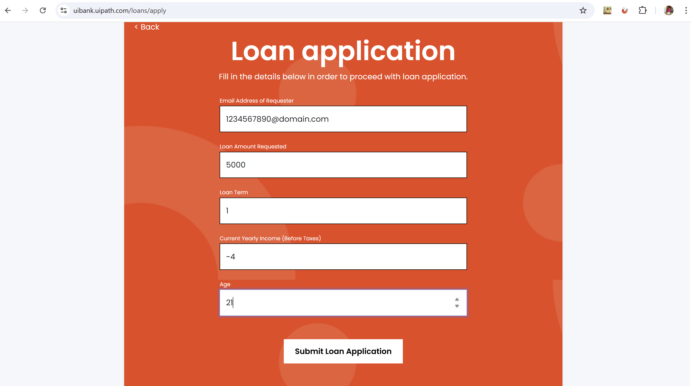

3.Grammerly extension:
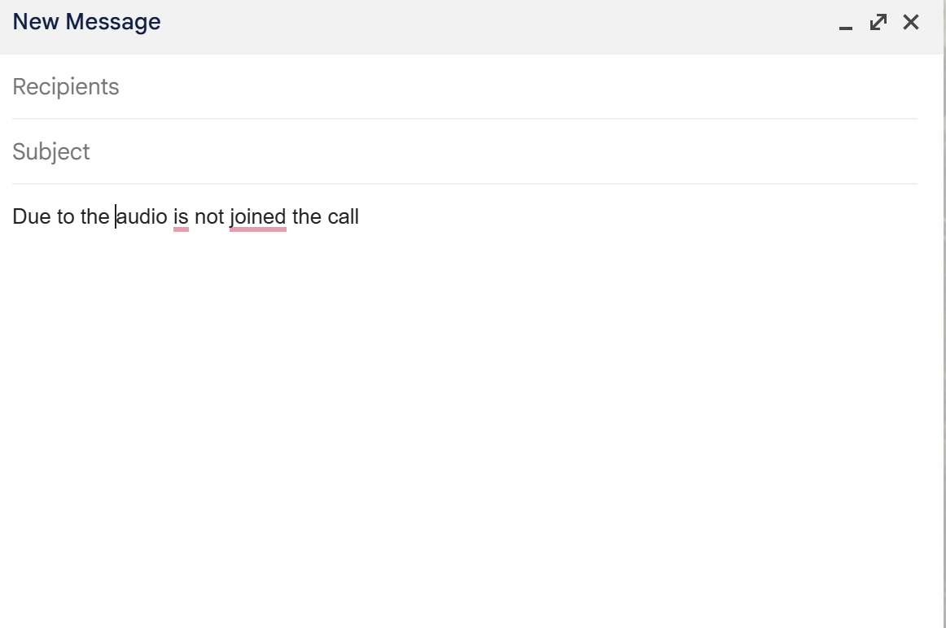
Corrected one
